🚀 Project 1 — E-Commerce Sales & Customer Analytics
One-liner
Build an end-to-end analytics system that uses Python and SQL to analyze e-commerce sales, customer behavior, and product performance, then presents the findings through an interactive Power BI dashboard.

🎯 Problem
Sebuah online store punya ribuan transaksi, tapi datanya tersebar dan sulit digunakan untuk menjawab:
- Produk apa yang paling menghasilkan revenue?
- Customer mana yang paling valuable?
- Bagaimana revenue berubah setiap bulan?
- Negara/region mana yang paling profitable?
- Apakah sales sedang naik atau turun?
- Customer seperti apa yang paling sering membeli?
Kamu akan membuat sistem untuk mengubah raw transaction data → actionable insights.

🏗️ Project Architecture
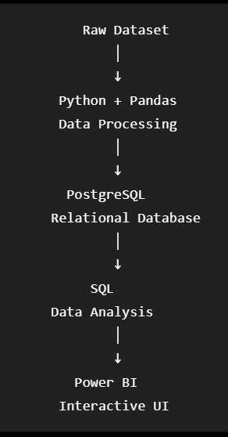
Jadi satu project ini bisa menunjukkan:
Python ✅
SQL ✅
Database ✅
Data Analytics ✅
Power BI ✅

📦 Dataset Structure
Cari dataset yang punya struktur semacam:
Customers
- customer_id
- name
- country
- signup_date
Products
- product_id
- product_name
- category
- price
Orders
- order_id
- customer_id
- order_date
Order Items
- order_id
- product_id
- quantity
Dengan ini kamu bisa latihan relational database + JOIN, bukan cuma query satu CSV.

🐍 Phase 1 — Python
Pertama kamu gunakan Python untuk memahami dan memproses dataset.
Pelajari/practice:
Pandas
↓
load data
↓
inspect data
↓
identify issues
↓
transform
↓
export
Contoh:
import pandas as pd

df = pd.read_csv("orders.csv")

print(df.head())
print(df.info())
print(df.describe())
Nanti kamu akan belajar melakukan transformation yang memang relevan dengan dataset.

🗄️ Phase 2 — SQL
Masukkan data ke PostgreSQL.
Lalu mulai dari query sederhana:
SELECT *
FROM orders;
Kemudian naik:
SELECT
customer_id,
SUM(quantity * price) AS total_spending
FROM order_items
GROUP BY customer_id
ORDER BY total_spending DESC;
Lalu:
Intermediate
- JOIN
- GROUP BY
- HAVING
- CASE WHEN
- subqueries
Advanced
- CTE
- Window functions
- ranking
- running totals
- month-over-month analysis
Jadi kamu belajar SQL sambil menyelesaikan problem, bukan menghafalkan query.

📊 Phase 3 — Business Questions
Ini bagian yang membuat project-nya terasa real.
Kamu harus menjawab minimal 10 questions:
Sales
- What is total revenue?
- What is monthly revenue?
- What is average order value?
- Which products generate the most revenue?
Customers
- Who are the top 10 customers?
- Which countries generate the most revenue?
- How many new customers join each month?
- What percentage of customers make repeat purchases?
Products
- Which categories perform best?
- Which products have high sales volume but low revenue?

📈 Phase 4 — Power BI
Dari hasil analysis, buat dashboard.
Page 1 — Executive Overview
TOTAL REVENUE TOTAL ORDERS
$1.24M 8,420

CUSTOMERS AVG ORDER VALUE
5,210 $147

Monthly Revenue
📈📈📈📈📈
Page 2 — Product Performance
- Top products
- Revenue by category
- Units sold
- Product ranking
Page 3 — Customer Analytics
- Top customers
- Revenue by country
- New vs returning customers
- Customer segmentation

⭐ Bonus Challenge
Kalau basic version sudah selesai, baru tambahkan:
RFM Customer Segmentation
Classify customers berdasarkan:
R — Recency
Kapan terakhir membeli?
F — Frequency
Seberapa sering membeli?
M — Monetary
Berapa banyak uang yang mereka keluarkan?
Hasil:
VIP Customers
Loyal Customers
Potential Customers
At Risk
Inactive
Ini bikin project kamu naik level karena mulai masuk customer analytics.

📁 GitHub Structure
Jangan cuma upload notebook. Bikin repo yang rapi:
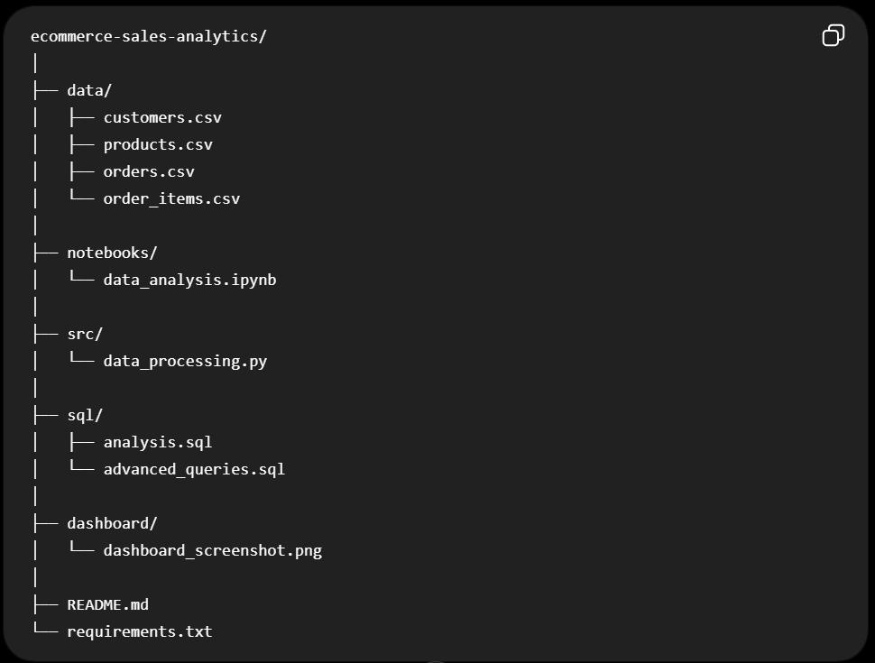
Jangan upload dataset kalau license-nya melarang. Bisa kasih link ke sumber datasetnya.

